**Staff Registration**

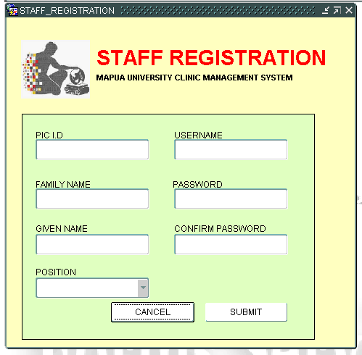

This form will be for the staff registration in which the first-time users are required to create an account, inserting their PICID or the Person In Charge Identification, Username, Family Name, Given Name, Position (Doctor or Nurse) and the password together with its confirmed password at the second item would allow them to create an account. All the data are then being inserted to the **PERSONINCHARGE** and **ACCOUNT** table of the main database.

**Login Form**

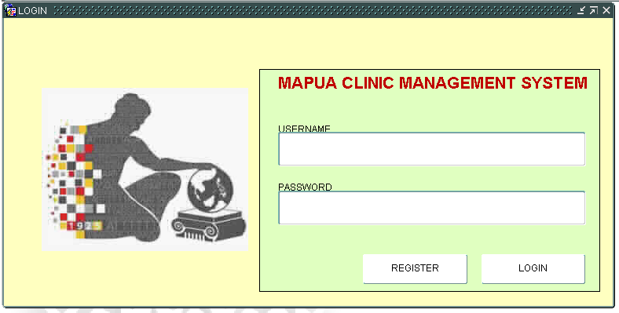

The login screen will ask for the username and the password of the user, it will then fetch the data from the **PERSONINCHARGE** and **ACCOUNT** table to see if the valid credentials are met, if the credentials is/are wrong, then it would display a console message “THE USERNAME OR PASSWORD IS INCORRECT!”.

**Homepage**

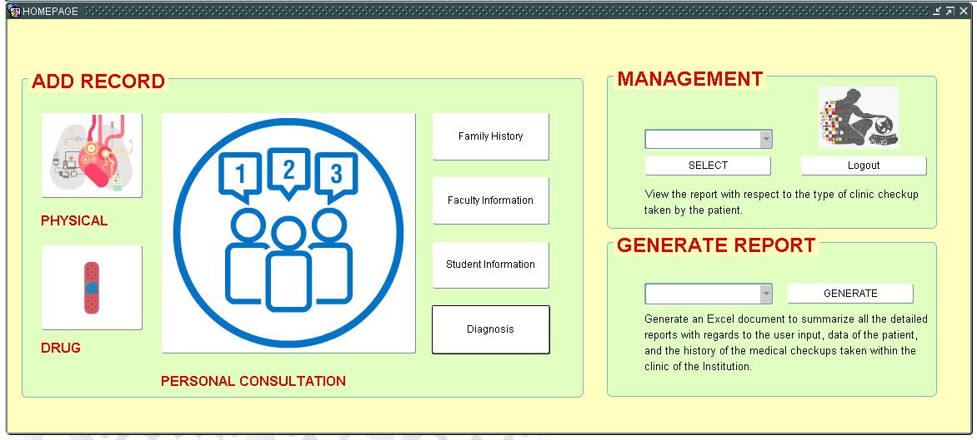

The homepage will only be then displayed if the user has valid credentials in which after pressing the login button from the login form, they will then be transported to the homepage form in which they will see three divided panels:

1. Add Record: Responsible for inserting a record for the Physical Examination, Drug Prescription, Personal Consultation, Family History, Faculty Information, Student Information, and Medical Diagnosis of the patient.
2. Management: It would allow the user to view the records of the patient, based from what they had inserted from the Add Record Panel.
3. Generate Report: It would generate an excel file for a summarized report of the patient.

**Diagnosis Insertion Form**

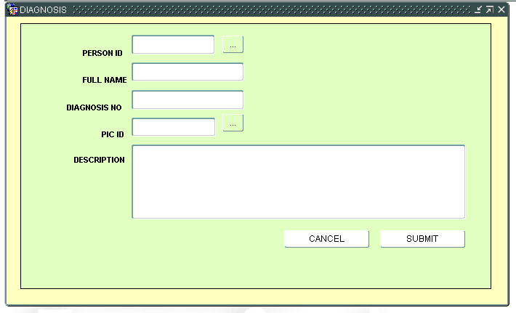

The diagnosis form will only be used when the patient is not feeling well, in which the user would select the PERSON_ID from the LOV that can be prompted by pressing the button at the right. The user will then insert the diagnosis description of the patient, PIC ID, and the diagnosis number, and then press the submit button to insert the data or cancel to go back to the homepage.

**Drug Prescription Form**

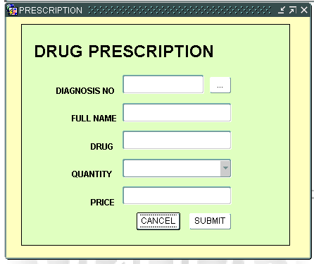

The drug prescription form will only be used when there is a record for the medical diagnosis since the user cannot prescribe a drug to the patient without having an actual diagnosis checkup with them. In here, the user will press the button at the right to display all the records of the medical diagnosis of all the patient, and then insert the name of drug, select the number of quantity, and type in the price.

**Faculty Registration Form**

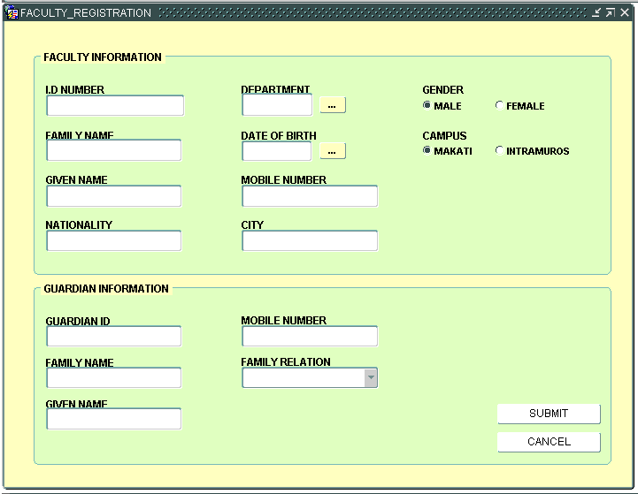

The Faculty Information will allow the user to create the patient record for all the faculty members within the Mapua. It would ask for the I.D Number of the patient, Family Name, Given Name, Birth Nationality, City, Mobile Number, Gender, and Campus for getting the information of the faculty, meanwhile there is another panel that is reserved for the guardian of the patient, which will need a Guardian I.D Number, Family Name, Given Name, Mobile Number, and Family Relation, additionally, it would ask for the department and date of birth of the faculty member.

**Student Registration Form**

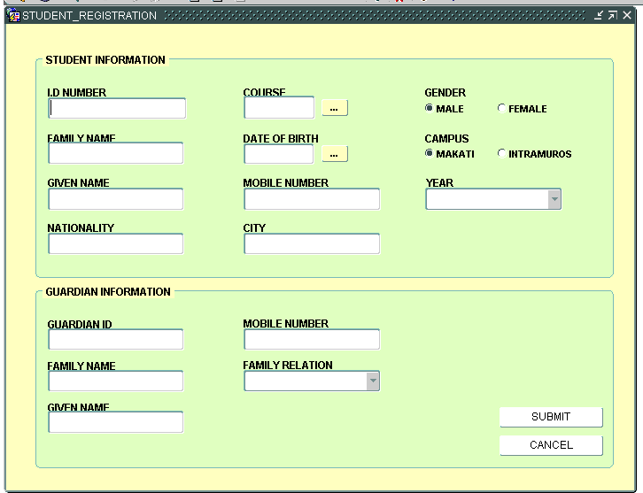

The Student Information will allow the user to create the patient record for all the faculty members within the Mapua. It would ask for the I.D Number of the patient, Family Name, Given Name, Birth Nationality, City, Mobile Number, Gender, and Campus for getting the information of the faculty, meanwhile there is another panel that is reserved for the guardian of the patient, which will need a Guardian I.D Number, Family Name, Given Name, Mobile Number, and Family Relation, additionally, it would ask for the course and date of birth of the student

**Family History Insertion Form**

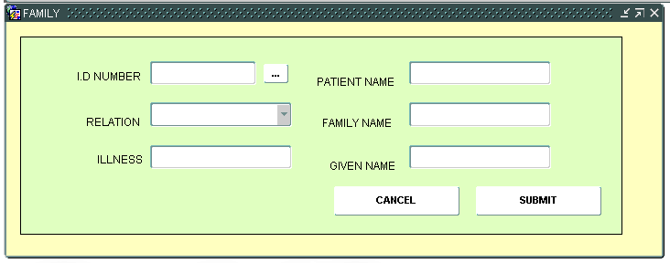

The Family History form would allow the user to input the direct family members of the patient, together with their recorded diagnosis since the data would be used for future reference if the patient will have another diagnosis or seizures. They are only limited to father, mother, sister, and brother in terms of inserting a relation.

**Physical Exam Insertion Form**

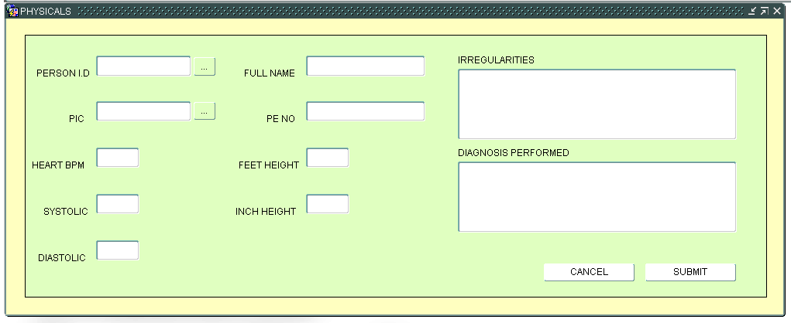

The Physical Exam Form would get the basic details of the recorded physical exam of the patient, it would ask for the I.D number of the person via pressing the LOV Button.

**Personal Consultation Form**

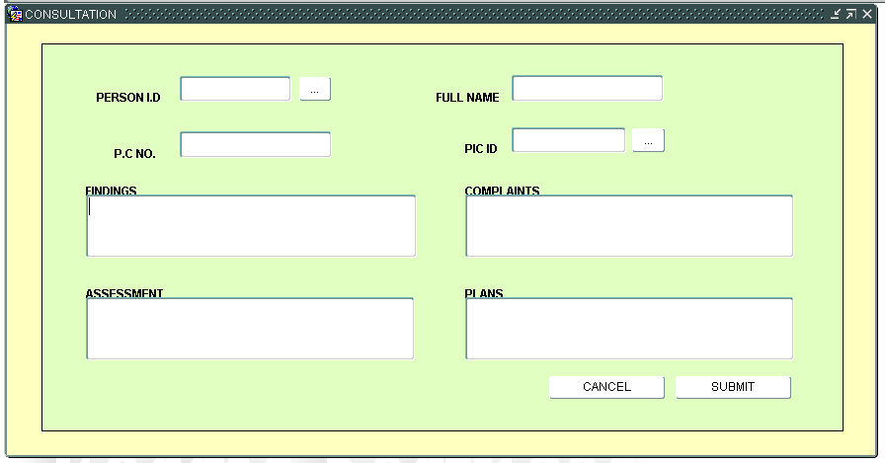

The consultation will allow the user to input the S.O.A.P Record of the patient:

1. For the **SUBJECT COMPLAINTS,** the nurse or the doctor will input the complaints of the student or the faculty with regards to their illness as exactly as what the student or the faculty said.
2. For the **OBJECTIVE FINDINGS,** the nurse or the doctor will input the things that they did to the student or the faculty, in here the evidence comes in that the student or the faculty indeed has that kind of sickness
3. For the **ASSESSMENT**, the nurse or the doctor will input the things that they did to the student or the faculty
4. For the **PLANS,** the nurse or the doctor will input the advice and instructions for the student/faculty.

**Diagnosis and Drug Information Form**

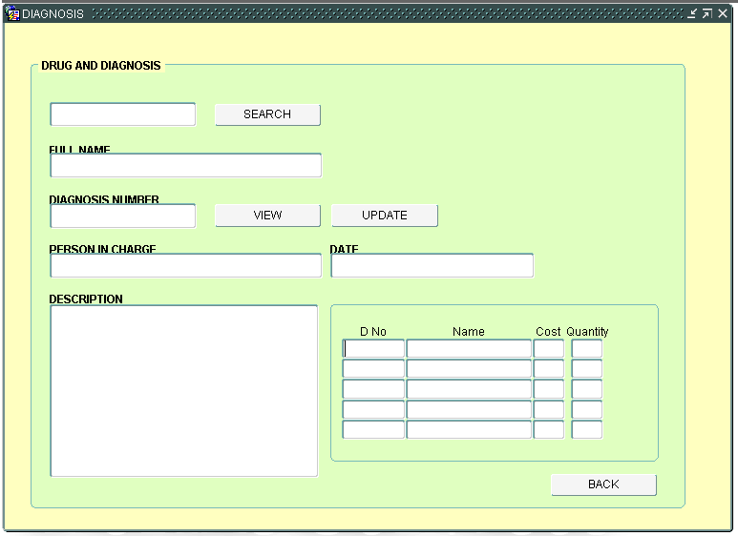

The Diagnosis form in terms of viewing will display the combined result of the Diagnosis Form and the Drug Prescription Form, in which the user can only edit the diagnosis description of the patient. This form will allow the user to view the drug prescriptions to the patient, date of diagnosis, and the person in charge during the diagnosis session when it was recorded.

**View Family History Form**

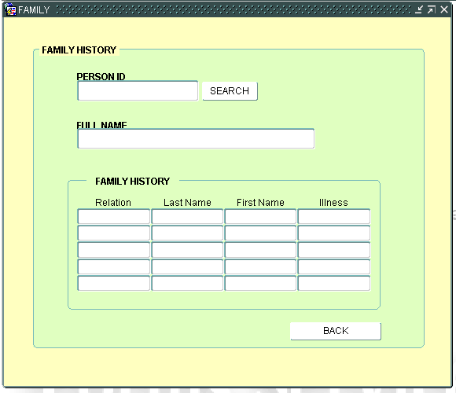

The Family History View Form will display all the records of the family history of the patient, including their relation, name, illness, and the name of the patient, in that way, the clinic would be able to know if there’s something wrong if the patient has a similar illness to them or not.

**View Patient Information Form**

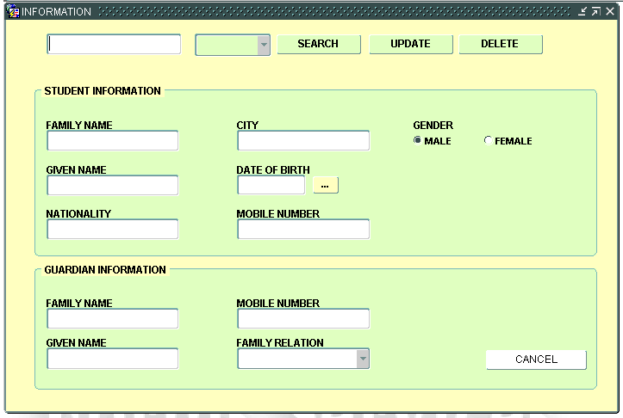

The Information View Form will then display information of the student or the faculty depending on what the user selected from the poplist, and then by clicking the search button, it will display all the I.D Number of the patient depending on what type of patient that the user selected.

**View Consultation Form**

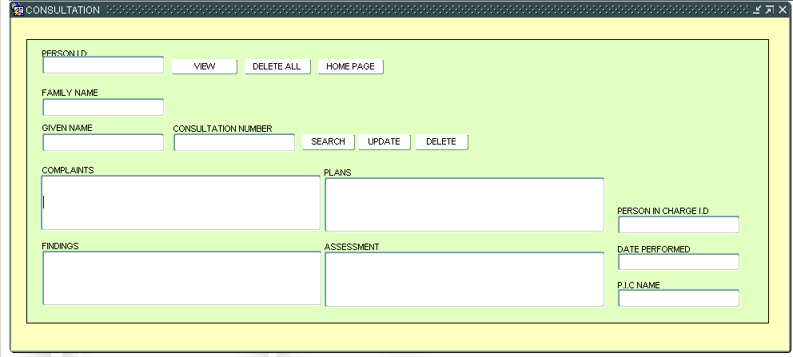

The Consultation View Form will display the recorded consultation of the patient.

**View Physical Examination Form**

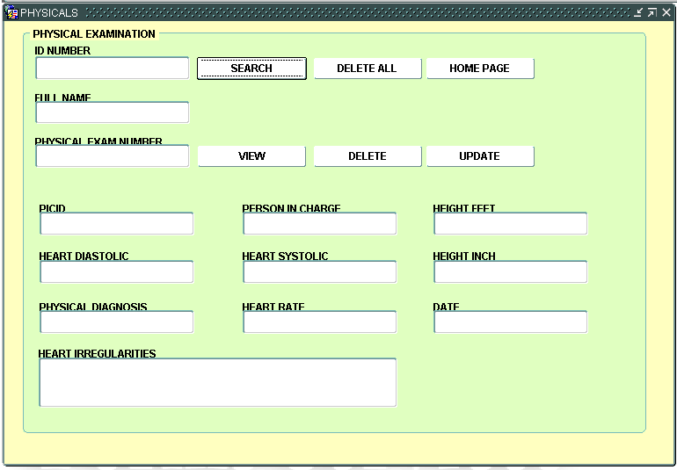

The Physical Exam View Form will display all the recorded Physical Exam of the Patient, the patient could either have more than one record of Physical Examination, the user then can view this by clicking the View LOV button.